One-Way ANOVA – Example 2 (Alternative Treatments for Depression) – Answer Key
There have been a wide variety of treatments for depression over the years, many of which would be considered “alternative” treatments. A group of participants who suffered from mild depression each participated in one of the following conditions. Each score represents the level of depression reported following a six-week program of relaxation, acupuncture, yoga, or weight training. Analyze the data using the appropriate statistical test.

Step 1. State your hypotheses.
a. Research hypotheses
H_{A}: At least one condition among relaxation, acupuncture, yoga, or weight training has a different
effect on depression than the other conditions.

H₀: There is no difference among the effects of relaxation, acupuncture, yoga, or weight training
on depression.

b. Statistical hypotheses
H_{A}: not all μs are equal

H₀: µ_{relaxation} = µ_{acupuncture} = µ_{yoga} = µ_{weight training}

Step 2. Set the significance level ➔ α = .05 Determine F_{crit}. F_{crit} = _3.49____

df_{between} = 3 df_{within} = 12

df_{between} = k – 1 df_{within} = N_{tot} – k df_{tot} = N_{tot} – 1 df_{tot} = df_{between} + df_{within}
= 4 – 1 = 16 – 4 = 16 – 1 = 3 + 12
= 3 = 12 = 15 = 15

Step 3. Select and compute the appropriate statistic and then complete the source table.
SS_{tot}= ∑(X - M_{tot})²
Relaxation X₁ | Acupuncture  X₂ | Yoga  X₃ | Weights  X₄
4 | 3 | 2 | 1
5 | 7 | 9 | 3
8 | 9 | 3 | 4
10 | 4 | 6 | 3
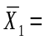6.75 | 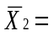5.75 | 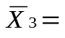5 | 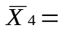2.75
X₁ M_{tot} X-M_{tot} (X-M_{tot})²
4 5.06 -1.06 1.12
5 5.06 -.06 .004
8 5.06 2.94 8.64
10 5.06 4.94 24.40
X₂
3 5.06 -2.06 4.24
7 5.06 1.94 3.76
9 5.06 3.94 15.52
4 5.06 -1.06 1.12
X₃
2 5.06 -3.06 9.36
9 5.06 3.94 15.52
3 5.06 -2.06 4.24
6 5.06 .94 .88
X₄
1 5.06 -4.06 16.48
3 5.06 -2.06 4.24
4 5.06 -1.06 1.12
3 5.06 -2.06 4.24
114.88 = SS_{tot}
SS_{within}= ∑(∑(X – M_{group})²)

X₁ M₁ X₁-M₁ (X₁-M₁₎² X₂ M₂ X₂-M₂ (X₂-M₂₎²
4 6.75 -2.75 7.56 3 5.75 2.75 7.56
5 6.75 -1.75 3.06 7 5.75 1.25 1.56
8 6.75 1.25 1.56 9 5.75 3.25 10.56
10 6.75 3.25 10.56 4 5.75 1.75 3.06
∑(X₁-M₁₎²=22.74 ∑(X₂-M₂₎²=22.74

X₃ M₃ X₃-M₃ (X₃-M₃)² X₄ M₄ X₄-M₄ (X₄-M₄)²
2 5 -3 9 1 2.75 -1.75 3.06
9 5 4 16 3 2.75 .25 .06
3 5 -2 4 4 2.75 1.25 1.56
6 5 1 1 3 2.75 .25 .06
∑(X₃-M₃₎²=30 ∑(X₄-M₄₎²=4.74

SS_{within} = 22.74 + 22.74 + 30 + 4.74 = 80.22
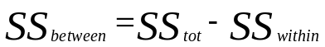

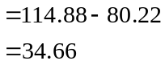

Source | SS | df | MS | F
Between | 34.66 | 3 | 11.55 | 1.73
Within | 80.22 | 12 | 6.69
Total | 114.88 | 15 |  | F_{crit} = 3.49

Step 4. Make a decision. Determine whether the value of the test statistic is in the critical region. Draw a picture. Label F_{crit} and F_{obt}. Is F_{obt} in the critical region? ___No____
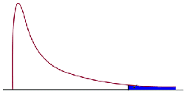
F_{crit} = 3.49
F_{obt} = 1.73
Step 5. Report the statistical results.

F(3,12) = 1.73, p >.05

Step 6. Write a conclusion.
The means of the Relaxation, Acupuncture, Yoga, and Weights groups are 6.75, 5.75, 5, and 2.75, respectively. The ANOVA did not reveal a significant difference among the groups in level of depression, F(3,12) = 1.73, p >.05.

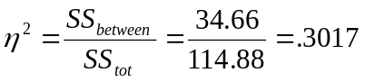Step 7. If appropriate, compute eta-squared and write a conclusion.

Type of treatment accounts for 30.17% of variability in level of depression.

